August 22nd 2014

POM PROMO TEAM BEING BUSY OUT IN STORES!
Check out the Kingston Promo Team with the Dazzle Laundry Powder evening shift awareness at the store near you.
With our evening shifts, Kingston promotion team brings to you the Dazzle Laundry powder awareness. Product awareness are carried out in stores such as Boroko Food world, SVS Harbor City, RH Vision City and Water front food world within the Nation’s Capital, targeting the evening shoppers. The Product Awareness is done from 5pm till 8pm on Thursday and Friday evenings and on Saturdays from 1pm to 3pm.
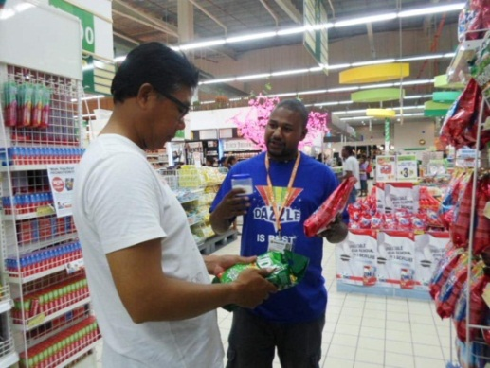

(Above) Robert giving awareness on Dazzle Laundry powder at Water front food world harbor city.

In Addition: THE GOLD ‘N’ SUN & TUFFA PROMOTION.
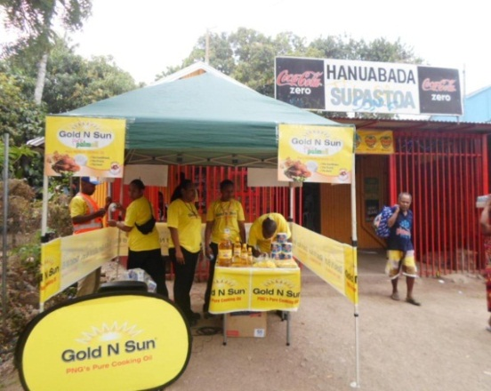

(Above) Kingston Promo Team, POM based carried out a promotion at a local store in Hanuabada.

