MEDIA RELEASE

For Urgent Release

Monday 9th JUNE 2014

“Sawyer Water Purifier draws interest from the General public on the World Environment Day.”
_________________________________________________________________
The general public within the Nation’s capital participated together to commemorate the World Environment Day which was staged on the 7th June 2014 at the Nature’s Park, Botanical Garden.
Being part of the event, KK Kingston Sales Promotion team demonstrated the Sawyer water purifier to the general public which brought in interested persons to the company booth to learn and understand more about the usage of the sawyer purifier.
The team has planned to carry out more awareness to the villages within the Central Province on the usage and the importance of the Sawyer water purifier.
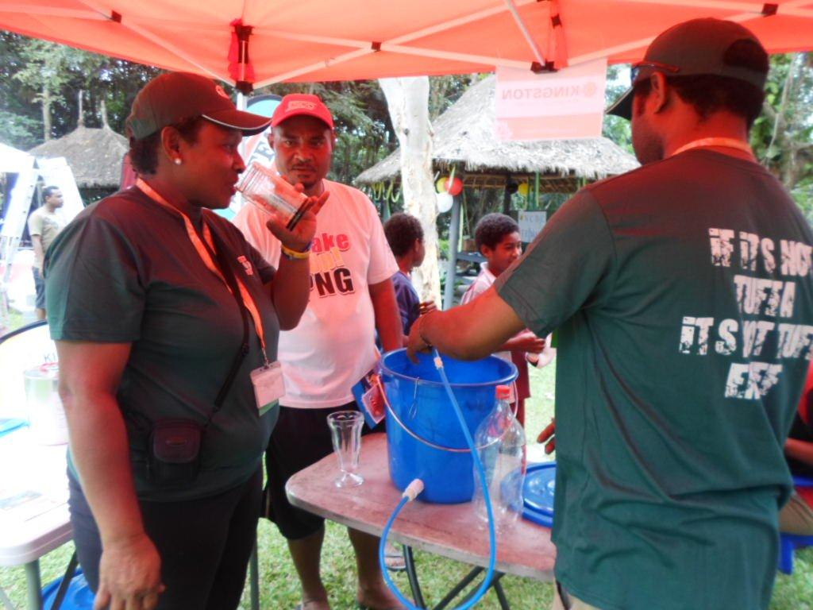
Gwen Moide having a glass of water after the water has been purified with the Sawyer Water Purifier.

Release ENDS: For more information contact: KK Kingston Marketing Department

